Volume I Reconnaissance study Smibelg Hydro Power Plant

Acknowledgment

Contents

LIST OF FIGURES VI

LIST OF TABLES VI

LIST OF ABBREVIATIONS AND ACHRONYMES VII

1 EXECUTIVE REPORT 2

1.1 Introduction 2

1.2 Key Results of the Study 2

1.2.1 Power production and cost 2

1.2.2 Base case Economic Analysis 2

1.2.3 Environmental Impacts 2

1.3 Brief Description of Recommended Project 2

1.3.1 Civil structures 2

1.3.2 Electromechanical Equipment 2

1.3.3 Key Project Characteristics 2

1 INTRODUCTION 1

1.1 Previous Studies 1

1.2 Scope of the present study 1

1.3 Project location 2

1.3.1 Project Catchment Features 3

1.3.2 Environment 3

1.4 Planning criteria 5

1.5 Power Market and Energy price 5

1.6 Site visit and data collection 5

1.6.1 Data 5

2 REGIONAL GEOLOGY 6

2.1 Geological units 6

2.1.1 Bed rock Geology 6

2.1.2 Soil cover 7

2.2 Seismic Hazard 7

2.3 Limitations 8

3 HYDROLOGICAL ANALYSIS 8

3.1 Hydrological data and analysis 8

3.1.1 Specific Runoff 8

3.1.2 Mean Flow 9

3.1.3 Design Flow 9

3.1.4 Utilization Factor 9

4 SCHEME IDENTIFICATION 10

4.1 Methodology 10

4.1.1 Catchment Identification 10

4.1.2 Topographic Analysis 10

4.2 Scheme Identification 11

4.3 Layout of Proposed Alternatives 12

4.4 Scheme Components 13

4.4.1 Diversion and Intake Structures 13

4.4.2 Water ways 13

4.4.3 Surge Chambers 14

4.4.4 Power station 16

4.4.5 Mechanical and Electro technical works 16

4.4.6 Out fall 17

4.4.7 Review and Enhancement 18

4.5 Scheme Summary 18

5 HYDRAULIC AND ENERGY ANALYSIS 19

5.1 Hydraulic calculations 19

5.2 Energy computations 19

6 COST ESTIMATION 20

6.1 General Cost Estimation Basis 20

6.2 Estimate Civil works 20

6.2.1 Dam and Intake 21

6.2.2 Water ways 21

6.2.3 Power House 21

6.2.4 Accesses Road 22

6.3 Estimate Mechanical and electro technical Equipment’s 22

6.3.1 Mechanical Equipment’s 22

6.3.2 Electro Technical Equipment’s 22

7 ECONOMIC AND FINANCIAL ANALYSIS 23

7.1 Economic and financial analysis 23

7.2 Comparison of the financial analysis methods 24

8 CONCLUSION AND RECOMMENDATION 25

# LIST OF FIGURES

Figure 1 Project Catchment Location Map (NVEAtlas, 2014) 2

Figure 2 Bed rock geology of project Catchment, Nordland (NGU, 2014) 7

Figure 3 Soil cover of project Catchment (NGU, 2014) 8

Figure 4 Guide Curve for Turbine Type Selection 17

Figure 5 Variation for unit cost of Generation 26

# LIST OF TABLES

Table 1 Elevation Hypsography of project Catchments Source: (Lavvann, 2014) 3

Table 2 land use pattern Source: (Lavvann, 2014) 4

Table 3 Project Sub - Catchment at selected Intake points, Lavvann output. 11

Table 4 Summary of Proposed Tunnels 14

Table 5 Summary of Pipes to be installed 14

Table 6 summary of Schemes with key planning parameters 18

Table 7 summary of Independent Scheme Alternatives 19

Table 8 Financial analysis and ranking summary 25

# LIST OF ABBREVIATIONS AND ACHRONYMES

|  |  |
| --- | --- |
| A | Catchment area |
| asl | Above sea level |
| B | Net benefit |
| B/C | Benefit – Cost Ratio |
| D | Pipe diameter |
| DI | Ductile iron |
| E | Energy production |
| F | Specific runoff |
| FIRR | Financial internal rate of return |
| g | Acceleration due to gravity |
| GWh | Giga watt hour |
| GWh/yr | Giga watt hours per year |
| Hg | Gross head |
| Hn | Net head |
| i | Discount rate |
| iRR | Internal rate of return |
| K | Capital cost |
| km | Kilometres |
| Km2 | Square Kilometres |
| kW | Kilowatt |
| l/s | Litre per second |
| m | Meter |
| m3/s | Cubic meters per second |
| Mill | Million |
| MW | Megawatt |
| NOK | Norwegian Kroner |
| NPV | Net Present Value |
| npv | Net present value |
| NVE | National Directorate of Water and Environment |
| PE | Polyethylene |
| PW | Present worth |
| Δt | Time period |
| q | Flow rate per second |
| Q | Annual flow rate |
| s | Second |
| W | Watt |
| yr | Year |

Structure of the Pre-feasibility Report

Volume I Reconnaissance Report

Volume I is the Reconnaissance Report, a stand-alone volume that details a complete picture of the project alternatives and the main results including the conclusion for the recommended project for detailed pre-feasibility study in Volume II.

Details including the studies and analysis with in the various fields [geology, hydrology, sediments, hydraulic analysis, economic analysis, etc.] are given in separate sections and annexes.

Volume II Main Report

Volume II is the main Report, a stand-alone volume that describes a complete detail picture of the recommended project and the main results of the analysis to a pre-feasibility level of study.

Details including the studies and analysis with in the various fields [geology, hydrology, sediments, hydraulic analysis, economic analysis, etc.] are given in separate sections and annexes.

Volume III Project Drawings

Volume III documents various project drawings in the form of drawing sheets for the recommended project.

Volume IV Various Analysis

Volume IV documents various project analysis results in the form of annex for each analysis section.

# EXECUTIVE REPORT

## Introduction

## Key Results of the Study

### Power production and cost

### Base case Economic Analysis

### Environmental Impacts

## Brief Description of Recommended Project

### Civil structures

### Electromechanical Equipment

### Key Project Characteristics

Volume I Reconnaissance Screening of Project Alternatives

# INTRODUCTION

The first volume of this thesis report will detail the reconnaissance investigation for hydro power potential assessment of kystfelt, Sørfjordelva and Kjerringåga river basins located in Rødøy Municipality, Nordland Norway. The catchment includes all rivers discharging to Gjervalen and Aldersundet from the mountain top of Nubben, Fjellet and Strandtinden. The report will give details on methodology, assumptions and results undertaken during the reconnaissance report.

## Previous Studies

SKS Produksjon undertook the project site identification and study for concession permit for ministry of water and energy for licencing in 2005 and has got permission for development in March 2012.

SKS concession plan is taken as a single alternative in the reconnaissance assessment during power potential investigation of the catchment and its feasibility is evaluated with the other ten identified interdependent potential development projects.

## Scope of the present study

This thesis will envisage the identification and assessment of the potential alternatives in the project site through a stepwise comprehensive planning and economic analysis to evaluate the feasibility of potential schemes with respect to technical, economic, environmental and socio economic aspects; hence, the report will state the preliminary proposed plans for alternative development options and finally prepare a refined prefeasibility level report for the recommended project.

The study will analyse and document all important aspects for formal approval by Department of Hydraulic and Environmental Engineering, NTNU.

The main objectives of this screening report are:

* Provide comprehensive power potential assessment of the project catchment
* Identify suitable power projects that meet the planning criteria detailed below
* Assess the identified alternatives to the level required for reconnaissance study  
  the level of study is defined as that in Book no 5, planning and Implementation of hydro power projects, Hydro power development series (Raven, 1992)
* Perform preliminary economic assessment of the alternatives in order to compare the identified projects in terms of cost per Kwh of generation. Cost base have been defined as per NVE cost curves , (NVE, 2014)
* Recommend the best alternative for prefeasibility study in volume II

## Project location

The Smibelg hydropower project is located in the municipality of Rødøy, Nordland, Norway. The project site is located approximately 105 km west of Mo i Rana and 540 km north of Trondheim. The relative location of the catchment is 66024’5”:13010’55” latitude and longitude respectively and shown in Figure 1 below;

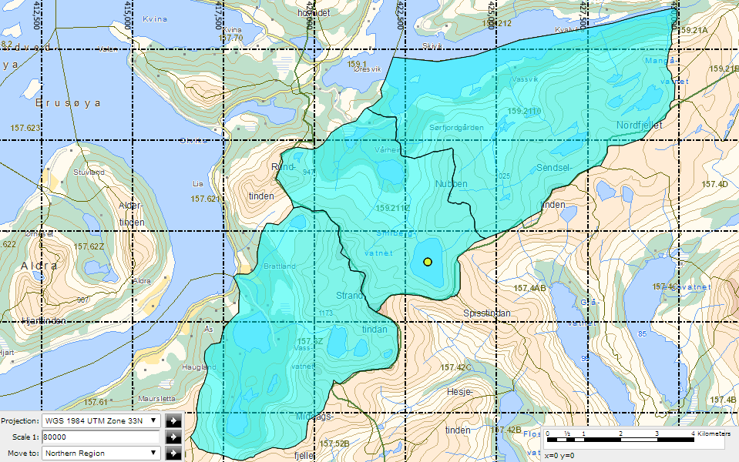

Figure 1 Project Catchment Location Map (NVEAtlas, 2014)

The project forms by using the water invasive approach of collecting water from effluent streams, lakes and the glacier deposit of the Nubben, Fjellet and Strandtinden mountain tops. The identified schemes will utilize the water from the existing mountainous rivers basins of kystfelt, Sørfjordelva and Kjerringåga, where the average annual precipitation rate is around 3000 mm/year.

### Project Catchment Features

The project catchment has approximately an area of 65.36 km2. The catchment has a length of approximately 6 km from the far end discharging point.

The catchment is characterized by four small river valleys directly discharging water forming their own drainage path down to the Norwegian Gjerval Sea. Steep mountain terrain is aligned on each side of the river valley making the catchment divide. The project will utilize the available flow by using a water collection system through tunnels and pipes to the desired intake location for optimum power production.

The elevation hypsography of the catchment varies from a minimum value of 0 to 1152masl and its distribution with in the catchment is shown below in Table 1. A small portion of the catchment (30%) is occupied with elevation less than 300masl; hence it will create a favourable ground for maximum power production.

Table 1 Elevation Hypsography of project Catchments Source: (Lavvann, 2014)

|  |  |  |  |
| --- | --- | --- | --- |
| Kjerringåga | kystfelt | Sørfjordelva |  |
| Elevation masl | Elevation masl | Elevation masl | % Comm. Area |
| 0 - 148 | 0 - 413 | 0 -168 | 10 % |
| 148 - 197 | 413 - 493 | 188 - 235 | 20 % |
| 197 - 249 | 493 - 575 | 235 - 350 | 30 % |
| 249 - 360 | 575 - 630 | 350 - 450 | 40 % |
| 360 - 480 | 630 - 674 | 450 - 506 | 50 % |
| 480 - 531 | 674 - 714 | 506 - 564 | 60 % |
| 531 - 613 | 714 - 750 | 564 - 627 | 70 % |
| 613 - 707 | 750 - 786 | 627 - 687 | 80 % |
| 707 - 827 | 786 - 864 | 687 - 748 | 90 % |
| 827 - 1160 | 964 - 1023 | 748 - 1152 | 100 % |

### Environment

The land use composition in the catchment comprises glacial mountain, marsh, forest and sea. The summary for areal coverage with in the catchment was taken from the available 1: 50,000 scale NVE web based map output, generally the project catchment is covered with glacier mountain tops and forest on down falling steep valleys in addition to that it includes scattered farm lands and five to six households located downstream of the main river Vassvikelva. The land use distribution for the project catchment is shown below in Table 2.

There are no severe environmental disturbances however environmental as well social impacts of the alternative schemes are left for consideration for the next level of study to recommend the need as well as extent of social and environmental investigation required at least with the following core study points.

* Need for resettlement
* Minimum flow requirement
* Restricted regions
* Cultural and historical values
* Recreational value and fisheries

Table 2 land use pattern Source: (Lavvann, 2014)

|  |  |  |  |
| --- | --- | --- | --- |
| Land use | Catchment | | |
|  | Sørfjordelva | kystfelt | Kjerringåga |
| Cultivated land | 0.1 % | 0.0 % | 0.7 % |
| Marsh | 0.6 % | 0.0 % | 0.7 % |
| Sea | 8.9 % | 5.0 % | 8.4 % |
| Forest | 16.5 % | 1.4 % | 28.5 % |
| Mountain | 69.9 % | 92.2 % | 58.2 % |
| Urban | 0.0 % | 0.0 % | 0.0 % |

## Planning criteria

The planning criteria for this level of study are directed solely based on the overall power demand of Norway; hence, the planning criteria taken in to the planning process lies in the identification of power plants which will support base load power demand to the existing nationwide grid. Under the firm power potential assessment the following list of economic criteria’s are considered:

* Unit cost of generation should not exceed generation cost of 0.6 Nok/Kwh
* Assessment should avoid already developed projects
* Incorporation of protected regions with in the catchment shall be minimized
* Environmental impact of the new development shall be assessed
* Integration in to the existing Norwegian national grid should be documented

## Power Market and Energy price

Power production has been increasing over the year, hence increased transmission capacity to fill the energy demand as a result a dynamic market has evolved where power can be bought and sold across regions and country easily.

In Norway the power market is deregulated in to a free market system which calls for variable power price that needs to be determined based on supply and demand just like other commodities.

## Site visit and data collection

The thesis work is planned to incorporate two field visits to the site one right after the reconnaissance assessment the other right after the design of the main component structures for confirmation on the location as well as geology of the identified site.

### Data

**Topographic map**: The Norwegian online web based platform covering the whole country is used from Norwegian mapping authority (StatnsKraftvek, 2014). A map scale of 1: 50,000 and below using Norgeskart and Gis link are used for topographic analysis of the catchment. Data gathered from the platforms for this level of study are geographical location, distance measurement and profiling of the selected section.

**Runoff map**: The Norwegian web based platform for water resource development maintained by (NVE, 2014) from NVE atlas and Lavvann with varying scale are used to examine the water resource potential of the project catchment. For this reconnaissance report they have been utilized to gather existing plants, location gauging stations and specific runoff at selected intake points respectively.

**Geological map**: The Norwegian Web based platform from the Norwegian geological society (NGU, 2014) is used for examining the bed rock geology and soil cover of the project catchment.

# REGIONAL GEOLOGY

Geological mapping and systematic investigation of the bed rock geology and soil cover of the project area is the key towards overall project cost and consequently to the feasibility of each alternative scheme. A preliminary geological investigation has been carried out for this level of study to foresee the existing geological units and soil cover of the project area and as such its influence in the hydro power development is stated.

## Geological units

The Scandinavian Peninsula is characterised by the “Baltic Precambrian Shield” (Hveding, 1992). Norway bedrock is comprised of approximately 2/3 Precambrian and 1/3 Palaeozoic (often referred to as Caledonian) units. These units are more than 230 million years old and are the basis for the hard rock environment of Norway. The geological units within the region are composed mainly of calc-alkaline intermediate volcanic rocks and intruded by granodioritic to granitic rocks (Skår, 2002).

The geological units within Norway, from a rock engineering point of view, are classified as being of high quality (Nilsen, 1993). Stability problems relating to weakness zones, faults, rock stresses, and unfavourable jointing are possible, and these need to be considered on a case by case basis at the specific project locations during the next phase of investigation.

### Bed rock Geology

The general bed rock geology in the project catchment is mainly dominated with øyegneis, granite and foliated granite. The details of bed rock geology as observed from the (NGU, 2014) are shown in the Figure 2 below. Granite is a good rock from engineering point of view as such its intact rock quality may influence the tunnel, cavern and trench excavation in the proposed alternatives; therefore detailed geological observation shall be done in the next level of investigation.

### Soil cover

There is no soil cover in the top mountain rather the topography of the area is exposed rock with undulating slopes and forest cover in the steep heel downfall as sited from aerial photo of the region. Generally the variation in depth and type of soil will have prominent influence in the final cost of the project. The soil cover distribution with in the catchment is shown in the Figure 3 below; the corresponding costing of the schemes in bare rock excavation is incorporated in section 6.

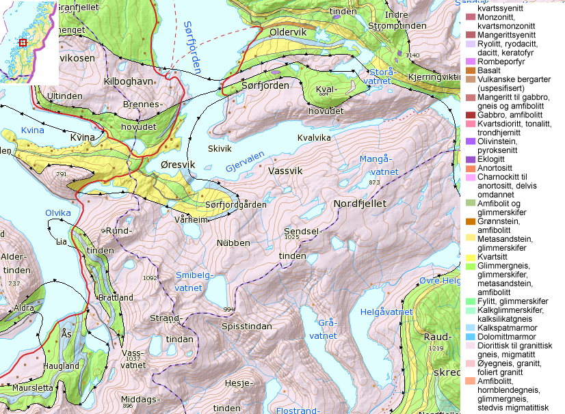

Figure 2 Bed rock geology of project Catchment, Nordland (NGU, 2014)

## Seismic Hazard

The seismic effect in the design of the alternative schemes are left for study for the next detailed prefeasibility study; however the seismic nature of the Rana region is known both from the fact that this was the location of the largest known earthquake in northern Scandinavia in recent times, Ms 5.6-6.5 earthquake of August 13, 1819 and relatively from its high and constant activity in 20th century (Erik C. Hicksa, 2000).

## Limitations

The variation in the bed rock geology and rock quality at key project component locations in the surface will influence the feasibility of each alternative scheme identified in section 4 of this report; therefore a detailed geological investigation shall be conducted in order to evaluate the merits of the development options and endeavour possible rock quality issues.

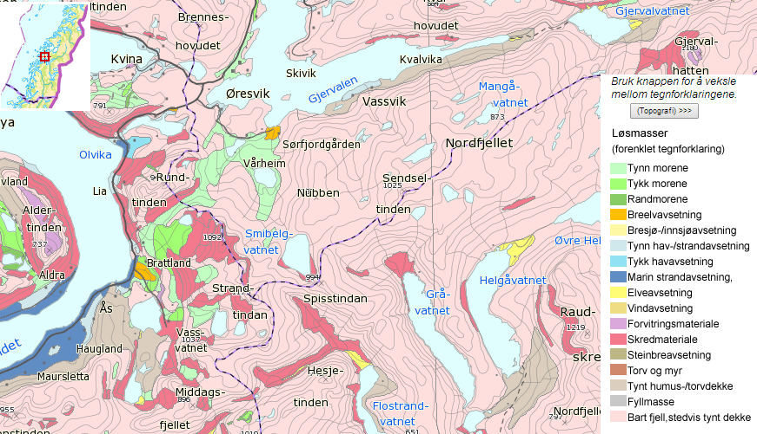

Figure 3 Soil cover of project Catchment (NGU, 2014)

# HYDROLOGICAL ANALYSIS

## Hydrological data and analysis

The inflow in to the system, from its contributing catchments and variation of the inflow over the year are the key to wards estimating the overall potential output. “Water is the basic source (or “fuel”) for hydro power generation and knowledge about the availability and its distribution is vital for both planning and operation of a hydropower system” (Killingtvet & Sælthun, 1995). The hydrological analysis has been undertaken and the results from the analysis are feed in to energy analysis described in section 5. The following step outlines the key steps undertaken for hydrological analysis.

### Specific Runoff

It is deemed advantageous to use Specific runoff maps from NVE Lavvann (NVE, 2014) for reconnaissance investigation and have been used for this level of study, the online platform uses flows from 1961-2014 to determine the average specific runoff values for the project catchment in agreement with the GIS platform to include the variation in the topography of the region.

### Mean Flow

The average flow at predefined intake points have been calculated by multiplying the specific runoff with catchment area for each sub catchment. The sum of each sub catchment mean flow included in each scheme is taken as the total available main flow for each scheme identified below in section 4.

### Design Flow

The design flow for this level of study is considered as two times the total average flow available in each scheme for dimensioning of project component structures. However detailed optimization analysis is required to determine the magnitude of the design flow and such analysis is mandatory in the pre-feasibility level study.

### Utilization Factor

Utilization factor indicates the percentage of the flow which a hydropower scheme is able to utilize for generation, flow duration curves are used as main tool in order to determine the utilization factor for the computed optimum design flow; basically two major factors influence the value for utilization factor:

* The proportion of time and the magnitude of events which exceed the maximum capacity of the hydropower scheme (Floods).
* The proportion of time and magnitude of events which are less than the minimum capacity of the hydropower scheme (Droughts, winter freezing of the river, environmental flows and minimum turbine flow).

As such to account for the above factors a generally accepted practical norm in the Norwegian hydropower Industry is used to determine the utilization factor of 68.5% to modify the design flow stated in section 3.1.3 above. The results of these assumptions are used in section 5 to compute the required hydraulic and energy analysis for this level of study.

# SCHEME IDENTIFICATION

The purpose of reconnaissance study was to identify as many schemes as possible satisfying the planning criteria stated above in section 1.4. This section of the report states the comprehensive rigorous assessment methodologies undertaken to identify the potential schemes for the project catchment. The summary of the identified schemes is detailed in section 4.5.

## Methodology

For this level of planning study, systematic identification of intake location, scheme alignment, storage possibilities, intra basin transfers, selection of required component structures etc. has been undertaken using comprehensive topographic and catchment analysis based on NVEs web based online platform. Details of the topographic and catchment identification are shown in separate section below.

Specific steps has been followed to maximize the key project qualities of a hydro power project, these are head and flow from the project catchment. The following preliminary steps have been followed to arrive at a suitable scheme:

* Catchment identification
* Major river identification
* Topographic analysis
* Scheme identification
* Selection of key project component location
* Review and enhancement

### Catchment Identification

The extent of the project catchments was delineated by the online web based platform NVE atlas (NVE, 2014) and shown in Figure 1 Project Catchment Location Map above through the highlighted section. The catchment divide enables to identify the cross catchment possibilities of tapping water from one catchment to the other to maximize the flow for increased generation capacity.

### Topographic Analysis

Detailed but preliminary topographic analysis has been undertaken to formulate the alternative schemes identified in the following section of the report focusing to maximize utilization of head and water available in the catchment. Long section of the river has been prepared for the four main rivers to foresee the extent of head concentration per meter length of the river using the GIS platform from Norgeskart (Norway, 2014) in addition to that relative cross-catchment possibilities are analysed and are detailed in annex A.

Intake locations are identified and catchment delineation followed by computation of average specific runoff were undertaken and summarized in the Table 3 below. Combination of sub-catchments through intra basin transfer using the advantage of existing natural topography was used to come up with unique schemes described below in section 4.2.

Table 3 Project Sub - Catchment at selected Intake points, Lavvann output.

|  |  |  |  |  |  |
| --- | --- | --- | --- | --- | --- |
| **Sno** | **Description** | **Elevation masl** | **Area Km2** | **Specific Runoff l/s/km2** | **Q av m3/s** |
| 1 | Nedre storåvatenet | 380 | 3.7 | 126 | 0.466 |
| 2 | Vakkersjordvatna | 400 | 6.2 | 119.5 | 0.741 |
| 3 | Mangåga | 571 | 4.2 | 121 | 0.508 |
| 4 | Smibelgvatnet | 506 | 4.4 | 133.6 | 0.588 |
| 5 | Storåga | 497 | 4.2 | 152.4 | 0.640 |
| 6 | Smibelg-1 | 499 | 0.6 | 153 | 0.092 |
| 7 | Smibelg-2 | 506 | 0.7 | 152 | 0.106 |
| 8 | Smibelg-3 | 498 | 0.1 | 119.6 | 0.012 |
| 9 | Østre vakker | 490 | 3.5 | 127.5 | 0.446 |
| 10 | Østre storåvatnet | 751 | 1.8 | 139.2 | 0.251 |
| 11 | Svartvatnet | 184 | 11.7 | 122.3 | 1.431 |
| 12 | Vassvatnet | 107 | 16.4 | 122.8 | 2.014 |
| 13 | Heimstadelva | 115 | 1.8 | 123.6 | 0.222 |
| 14 | Dalåga | 102 | 1.6 | 137.20 | 0.220 |

## Scheme Identification

The topographic analysis has been undertaken in two phases, these are:

* Identification of interdependent schemes to identify the effect of adding a sub-catchment at the expense of increased capacity and cost of the plant
* Rationalizing the identified interdependent schemes into independent schemes based on their economic merit and maximized power output.

Interdependent schemes were identified in the initial analysis to foresee the effect of adding a sub-catchment at the expense of the cost that the additional project structure might demand to add to the existing scheme. A total of eleven interdependent schemes are identified and summarized below in section 4.5.

Preliminary project costing and economic analysis described in section 7 has been conducted and resulted confirmation of feasibility for all schemes satisfying the planning criteria set above in section 1.4.

A total of five Independent schemes are selected upon feasibility of all alternative schemes towards maximized production output even if there were options with a smaller capacity that will give a smaller unit cost of development. The selected schemes are described as proposed alternatives in the following section and are documented in annex B.

## Layout of Proposed Alternatives

Alternative 1 describes Scheme 8 in scheme summary and it is the one proposed by SKS Produksjon for concession permit to NVE. The layout details are presented in map layout Drawing D1-A3. Alternative 2 to 5 are schemes proposed for this thesis work.

Alternative 2 describes Scheme 7 in scheme summary; the layout comprises a system of tunnels and pipes to tap all available flows with underground power house arrangement located under Loften Mountain north of river Vassvikelva. The layout details are presented in map layout Drawing D2-A3.

Alternative 3 describes Scheme 6 in scheme summary; the layout comprises a system of pipes and tunnels collecting water from all sub-catchments for an increased potential output, though in this scheme there will be a greater construction difficulty due to steep gradient from selected intake points to penstock start location. The layout details are presented in map layout Drawing D3-A3.

Alternative 4 describes scheme 10 the layout comprises a tunnel from Smibelg to Storåga and a penstock pipe taking the water from Storåga to Vassvatnet where the power house is located. The layout details are presented in map layout Drawing D4-A3.

Alternative 5 describes scheme 11 where the water flowing from the alternative four power plant scheme is taken along with other sub catchments and drops to a power house at Ågneset.

The layout details are presented in map layout Drawing D5-A3.

## Scheme Components

The identified alternative schemes has been evaluated with respect to scheme components required to finalize a complete picture of each alternative and the following section describes the assumptions and procedure’s undertaken for each scheme component under consideration.

### Diversion and Intake Structures

A small concrete gravity dam has been proposed for all scheme alternatives at this level of study since the topography of the project catchment favours runoff the river schemes except at Lake Smibelgvatnet and Storåga which allows storage of water with significant amount of storage as compared to the surrounding small lakes.

Reference has been made to NVE cost curve design standards for small dams having the following construction features, construction of dams in section of 6.1 m and foundation rock injection depth of 0.5 x H, where H the water depth at the highest regulated water level HRWL.

Brook and frontal intake types which includes intake pond, trash rack and a closing gate has been proposed to find the cheapest solution allowing optimum flow condition, whilst avoiding problems related with freezing of water and rock boulders entering into the intake.

### Water ways

Most but not all of the identified schemes are fitted with tunnels and pipes to transport water from one sub-catchment to the other. Here in this section of the report the theoretical basis behind the selection, optimization and design of tunnels and pipes are described.

Tunnels are proposed from Storåga to Smibelg, Smibelg to Østre Vakker and from Manåga to Nedre Storåvatnet to transfer the water from each catchment based on the topography, bed rock geology, economics and probable construction difficulties.

The alignment of the tunnels are aligned in such a way that they satisfy the minimum rock cover requirement, matches with the topography without losing head, technically easier for excavation methodology selection and economically attractive. Summary of proposed tunnels from all of the alternatives are described below in Table 4.

Table 4 Summary of Proposed Tunnels

|  |  |  |  |  |
| --- | --- | --- | --- | --- |
| Description | Tunnel | | | Remark |
| length m | A m2 | Excavation Method |
| Storåga to Smibelg | 2444 | 16.00 | Drill and blast | Free gravity flow |
| Smibelg to Østre Vakker | 2530 | 16.00 | Drill and blast | Free gravity flow |
| Manaåga to Storåvatnet | 2100 | 16.00 | Drill and blast | Free gravity flow |
| Penstock tunnel | 565 | varies but <10 | Directional drill | pressurized flow |
| Tail race tunnel | 300 | 16.00 | Drill and blast | Free gravity flow |
| Access tunnel | 600 | 30.00 | Drill and blast | Transport and accesses |

Design procedure

To assure the required stability requirement for tunnels summarized above the Norwegian rule of thumb principle is used to quantify the results. The minimum rock covers required against rock stress, squeezing and rock fall are calculated.

Preliminary penstock tunnel diameter optimization has been undertaken using simplified formula shown below; (Gunnes, 2000).

Where: A= area in m2 and Q = design discharge in m3/s

However, among other factors the cross-sectional areas of proposed tunnels are determined by the minimum area required for drill and blast by Norwegian tunnel contractors.

Buried Pipes are normally preferred as compared to tunnels in cases where the topography allows for pipe alternative; hence, DCI, PE and GRP pipes are compared in terms of the pressure and cost required per meter length of a pipe to be installed and all of identified projects are fitted with buried GRP pipes as the best alternative. The summary of the installations for the realization of the schemes are shown in Table 5.

### Surge Chambers

Preliminary surge analysis of the schemes shows surge shaft is not required to alleviate water hammer problem. For the analysis the time required for the generator to reach from zero to full load normal speed (Ta) is recommended to be in the range of 5 to 8 sec. generally to have a stable governing system which can adjust the power demand with water requirement at the turbine, the dynamic properties of the conduit system should satisfy the following rules.

> 6

Where: Ta = Time required for the generator to attain full load at normal speed

Tw = Penstock time constant, time that the penstock requires to reach from zero to maximum discharge under the influence of the available gross head.

Where: Q = maximum design discharge

H = Gross head

L = Length of tunnel plus penstock

A = Cross sectional area

L/A = from the nearest water surface upstream to the nearest water surface downstream

The computed penstock time constant will satisfy the governing rules hence surge shaft is not required, however detailed analysis on pressure in front of the turbine and governor stability are required and posted for the next level.

Table 5 Summary of Pipes to be installed

|  |  |  |  |  |
| --- | --- | --- | --- | --- |
| Description | pipe | | | Remark |
| length m | Diameter mm | Type |
| Nedre Vakker to nedre storåvatnet | 465 | Varies | GRP | Buried |
| Østre vakker to østre storåvatnet | 3000 | 2800 | GRP | Buried |
| Nedre storåvatnet to penstock | 1200 | Varies | GRP | Buried |
| Manåga to penstock | 1700 | 1650 | GRP | Buried |
| Surface Penstock |  |  |  |  |
| Scheme 1,3,5 | 565 | 1850,2100,2100 | GRP | Buried |
| Scheme 2 & 4 | 1432 | 1850,2100 | GRP | Buried |
| Scheme 9 | 1050.00 | 1950 | GRP | Buried |
| Scheme 10 | 1565 | 2000.00 | GRP | Buried |
| Scheme 11 | 700.00 | 2750.00 | GRP | Buried |
| underground penstock |  |  |  |  |
| Scheme 6 | 565 | 2700 | DCI | concrete Lined |
| Scheme 7 | 565 | 2700 | DCI | concrete Lined |
| Scheme 8 | 600 | 2550 | DCI | concrete Lined |

### Power station

The topography as well as capacity of the plant has a major influence for selection of power house type, hence for identified schemes of capacity less than 10 Mw a surface power house has been proposed.

For schemes greater than 10 Mw underground power house is proposed and is located in the Loften region having sufficient rock cover, good rock quality of granodiorite and short access tunnel. The capacity of the underground excavation is fixed using the blasted volume required using the following formula obtained from NVE cost curve (SWECO Norge AS, 2012). However the arrangement and details of the power house outline are left for pre-feasibility study.

Where: V = Blast Volume, m3

H = Net head, m

Q = Total maximum water flow, m3/s

n = Number of units

### Mechanical and Electro technical works

Turbines

Turbines are the main engines in any hydropower development and are used to convert potential energy of water in to rotational mechanical energy of turbine shaft which is coupled with the generator shaft, turbine type alternatives has been sought for the identified schemes taking the head and design flow as criteria from the following turbine selection design curve and two equal capacity Pelton turbine units are proposed except for Scheme 11 which is fitted with single Francis turbine at the expense of higher flow and low head.

At this level the possibility of using two turbines as compared to one is observed to fetch the extra advantage of using two units as compared to one unit. Hence, they will decrease the probability of power shutdown in case of sudden turbine breakdown and using two units of equal capacity will allow utilization of one spare part to maintain both units which will minimize the overall maintenance speed and cost; hence two units of equal capacity are provided for each scheme that has a capacity greater than 5 Mw and one unit for the rest.

Pelton turbines have a larger operational range and are able to be run with flows as low as 10 % of the maximum turbine discharge. This compares to Francis turbines which should not be run below approximately 40 % of the maximum turbine discharge. Minimum turbine flows are not incorporated into the hydrological analysis for this level and will have no effect on this study. This should be considered in further stages of investigation.

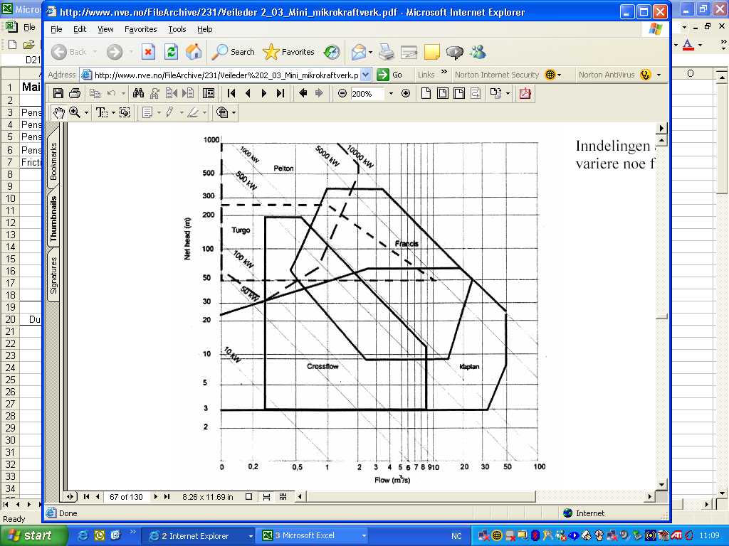

Figure 4 Guide Curve for Turbine Type Selection

### Out fall

The out fall for releasing the water back to the river are considered and the location of the power house nearby to river or lake is considered to ascertain the shortest possible distance and reduced cost.

The preliminary level for surface as well as underground arrangements is set at 10 masl, however for the next level explicit detailed analysis of river flood level as well as submergence requirement has to be cheeked to set the outlet level as per international design standard codes.

### Review and Enhancement

The full optimization is left for the next pre-feasibility study; hence it will put a challenge on the screening assessment of this study to the extent of feasibility of the recommended scheme. However the results are documented as reference for future assessment study.

## Scheme Summary

This screening assessment has identified 11 schemes passing the planning criteria set above and are summarized with a key parameters in Table 6.The layouts of each scheme are fitted with the topographic map and are presented along with the cost estimation and economic analysis in annex B.

Tabular summary of the independent schemes identified are presented in Table 7 with the basic technical and economic parameters. There is no existing developed hydro power plants in the catchment considered and as such no detail is presented.

A study for transmission and connection to the existing grid is not considered and therefore are posted for the next prefeasibility study, although there are potential transmission lines in the catchment understudy.

Table 6 summary of Schemes with key planning parameters

|  |  |  |  |  |  |  |  |
| --- | --- | --- | --- | --- | --- | --- | --- |
| **Sno.** | **Description** | **Intake level** | **Outlet level** | **Mean flow m3/s** | **Tunnel m** | **Pipe Trans m** | **Penstock Length m** |
| Scheme 1 | Storåvatnet | 382.00 | 10.00 | 1.21 | x | 1665.00 | 565.00 |
| Scheme 2 | Vakkersjordvatna | 379.68 | 10.00 | 1.21 | x | 465.00 | 1432.00 |
| Scheme 3 | Storåvatnet | 383.00 | 10.00 | 1.72 | 2100.00 | 1665.00 | 565.00 |
| Scheme 4 | Vakkersjordvatna | 379.68 | 10.00 | 1.72 | 2100.00 | 465.00 | 1432.00 |
| Scheme 5 | Loften | 383.00 | 10.00 | 1.72 |  | 3365.00 | 565.00 |
| Scheme 6 | Loften | 383.00 | 10.00 | 2.30 | 7594.00 | 465.00 | 565.00 |
| Scheme 7 | Loften | 383.00 | 10.00 | 2.94 | 7074.00 | 465.00 | 565.00 |
| Scheme 8 | Loften | 484.25 | 10.00 | 2.64 | 7680.00 | 3450.00 | 1100.00 |
| Scheme 9 | Svartvatnet | 187.00 | 10.00 | 1.43 | x | x | 1050.00 |
| Scheme 10 | Hundåga | 498.00 | 110.00 | 1.44 | 2444.00 | x | 1565.00 |
| Scheme 11 | Brattland | 102.00 | 10.00 | 3.25 | 2444.00 | 1175.00 | 700.00 |

Note: In the table above X should be understood as not provided/included.

Table 7 summary of Independent Scheme Alternatives

|  |  |  |  |  |  |  |  |
| --- | --- | --- | --- | --- | --- | --- | --- |
| **Sno.** | **Description** | **Intake level** | **Outlet level** | **Mean flow m3/s** | **Installed capacity** | **Turbine Type** | **Power House type** |
| Scheme 6 | Loften | 383 | 10 | 3.15338 | 20685.45 | 2 x pelton | Underground |
| Scheme 7 | Loften | 383 | 10 | 3.15338 | 20671.25 | 2 x pelton | Underground |
| Scheme 8 | Loften | 484.25 | 10 | 2.64309 | 22051.44 | 2 x pelton | Underground |
| Scheme 10 | hundåga | 502 | 110 | 1.43808 | 9914.56 | 2 x pelton | surface PH |
| Scheme 11 | Brattland | 104 | 10 | 3.25392 | 5333.51 | 1 x Francis | surface PH |

# HYDRAULIC AND ENERGY ANALYSIS

The assumption and details of hydraulic and energy calculation are stated in separate section below,

## Hydraulic calculations

To determine the available head for generation the probable hydraulic losses has to be deducted from the gross head. Hydraulic losses with in hydropower development can be classified in to three:

* Major loss from tunnels and pipes
* Minor loss at contractions, joints, bends, entrances etc.
* Turbine and generator losses

For this level of study the minor losses are not calculated rather they are included in the general simple hand rule of 1 m/km as a total loss in the conduit system. The losses in the turbine and generator are accounted using efficiency value of 90 % for the power calculation.

For transfers pipe and low pressure tunnels free flow with a velocity range of 0.7 to 1.5 m/s are considered and the manning roughness coefficient for pipes and tunnels are taken as 100 and 35 respectively. For penstock pipes flow velocity of 4 m/s and roughness value of 100 is considered in the analysis.

## Energy computations

To determine the energy potential of each identified scheme energy computation formula with some adjustment factors are stated below,

Where: E = Energy potential, GWh

= Density of water, Kg/m3

g = Gravitational acceleration, m/s2

q = Design flow, m3/s

= Time, hrs

U = utilization factor, 68.5%

The result of the energy analysis has been feed in to economic analysis to compute the overall probable benefit from each individual scheme. However storage possibilities for schemes that include Smibelg and Storåga will increase in secondary power and are considered as 10% of the total energy as added value in the economic analysis section of the report and the details of the optimization are posted for the next pre-feasibility study.

# COST ESTIMATION

## General Cost Estimation Basis

Cost base manual from NVE has been used to calculate the average foreseeable cost for contractors (Civil works) and supplier costs (mechanical and electro technical Equipment’s) for capacity less than 10 Mw and greater than 10 Mw generating capacity (SWECO Norge AS, 2012).

The prices in the report are as of 1 January 2010. The prices and costs are recorded in Norwegian kroners. No taxes, import duties and interest during construction are included in the cost estimate. The following section describes the assumptions and steps taken to estimate the cost of each project component and the summary cost estimate of each scheme are documented in annex C

## Estimate Civil works

This section provides a basis for calculating the average foreseeable contractors cost for civil work. Average foreseeable means there is a 50% risk of costs getting higher and a 50% risk they will be lower (SWECO Norge AS, 2012). With regard to uncertainty margins there is a 90% probability for real costs to be in the computed costs.

### Dam and Intake

For typical dam design reference is made to NVE cost base manual that are designed according to the regulations governing water course structures- dam safety regulations and guidelines for construction and maintenance of small dams (NVE, 2014).

The height of the dams are computed using the simple hand rule 3Ø and topography as a limiting factor, accordingly the costs of each proposed dam are calculated by multiplying the cost at maximum dam height by the river cross-sectional width at the damming point which is profiled using Norgeskart (StatnsKraftvek, 2014).

The proposed costs of intakes are calculated as a lump sum value using the maximum design discharge and capacity of the power plant for each alternative scheme.

### Water ways

#### Tunnels

Tunnel costs for small hydro power are generally lower than for large hydro power. The costs of tunnels are computed based on the cross-sectional area of each scheme multiplied with the length of the tunnel. 20% for rock support and 20% for preparing and running are included in the cost estimate.

#### Pipes

Materials examined during the cost analysis includes polyethylene (PE), glass reinforced polyester (GRP) and ductile cast iron (DCI). Technically based on the flow magnitude and pressure requirement of each scheme GRP pipes are found to be the cheapest pipe after comparing on NVE cost curves.

#### Penstock

Glass reinforced polyester (GRP) and ductile cast iron (DCI) pipes are the commonly used pipe materials for penstocks and in principle their foundation can be buried or laid on foundation blocks. Buried GRP pipes are proposed for surface power house schemes and DCI are proposed for underground schemes laying aside the unlined tunnel option at this level of study.

### Power House

Both surface as well as underground power house are proposed for the respective schemes, the cost is computed as lump sum value for surface power house using maximum discharge and gross head as limiting criteria to read from NVE cost curve. For the underground alternatives the following three steps have been followed to compute the cost of power house, these are:

* Calculate the station installation as N = 8.5 x Q x H in Kw and choose the number of units and type.
* Use the approximate estimate formula above in section 4.4.4 to compute the required blasted Volume
* Use the total building related contractors cost for blasting as 2250 Nok/m3.

### Accesses Road

The minimum road standard criteria for Norwegian road category 3 is adopted as a means for access road construction and the cost figures are taken using moderate to difficult terrain arrangement.

The costs comprise a fully prepared road including planning, staking out, digging, blasting, culverts, placing of base courses and gravelling. The scope of each operation such as blasting and transport of material will have a significant impact on the price.

## Estimate Mechanical and electro technical Equipment’s

Generally the cost of the total mechanical and electro technical equipment’s reaches up to 50% for hydro power developments. Estimation of the major component like turbine, generators, transformers, auxiliary system, pumps, control system and switching gear costs have been done and to account the unaccounted costs a 10% added cost of the calculated cost have been done to arrive at total cost.

### Mechanical Equipment’s

Turbines

The cost is derived from the cost curves based on the head and flow of each of the schemes. Both of the NVE cost estimation manuals are used for cost computation with their corresponding generating capacity.

### Electro Technical Equipment’s

Generators

Generally hydropower generators can be either air cooled for smaller capacities or water cooled for larger capacities; hence both options are recognized and selected based on the individual scheme capacity. Generator total cost is computed as a lump sum using capacity as the criteria for the cost curves.

The total cost for transformers, auxiliary system, switching gear and control system electro-technical equipment’s are computed based on schemes generating capacity and are computed as a lump sum value from cost curves of both manuals.

# ECONOMIC AND FINANCIAL ANALYSIS

## Economic and financial analysis

To determine the viability of the identified schemes a financial analysis is required. By evaluating the anticipated lifetime costs and benefits of the schemes a degree of clarity can be provided on the overall return on the investment and the sequencing of cash flows. Commonly used discounting techniques are used to compute and compare the ranking of the identified schemes. The details of the methodologies are summarized below,

For reconnaissance level of study the following economic tools have been evaluated to rank the identified projects.

* Net present value(NPV):

Calculates the net present value of the alternatives with preference being given to the alternative with the largest present worth

* Benefit cost ratio(B/C)

Calculates the net present value of the scheme benefits divided by net present value of the scheme costs.

B/C =PW b /PWC =

* Annual cost method

Converting all costs and benefits into equal annual figures allows the profit or loss over the lifetime of a project be expressed on an annual basis. Here the levelised unit cost is used for comparisons of the alternatives.

* Internal rate of return (IRR)

The internal rate of return is a measure of the return on the investment. The required IRR will vary between Clients based on the cost of financing that they can obtain and the IRR of alternative projects which they may have under consideration. The IRR of a scheme is calculated by setting the net present value equal to zero and determining the corresponding value of the IRR:

* Development rate

Development rate is a measure of the annual costs required during project lifetime at the expense of constant annual generation without outage of the power plant.

## Comparison of the financial analysis methods

Each of the above techniques has advantages and disadvantages with regard to the presentation and understanding of the results of the study. The ranking of schemes varies between the NPV and the other four analysis methods, and as such the definition of the optimum project relates directly to the investment profile, alternative opportunities, and needs of the client.

Summary of the financial analysis for independent schemes are shown in the table below,

Table 8 Financial analysis and ranking summary

|  |  |  |  |  |  |  |
| --- | --- | --- | --- | --- | --- | --- |
| **Economic Analysis** |  | Scheme 6 | Scheme 7 | Scheme 8 | Scheme 10 | Scheme 11 |
| Total investment cost | M nok | 285.6 | 283.7 | 302.0 | 141.9 | 117.7 |
| Net present value | M nok | 81.0 | 82.6 | 88.8 | 46.1 | -9.5 |
| Internal rate of return | % | 0.092 | 0.092 | 0.092 | 0.095 | 0.063 |
| Benefit cost ratio |  | 1.28 | 1.29 | 1.29 | 1.42 | 0.92 |
| Levelized Unit cost | Kr/Kwh | 0.47 | 0.46 | 0.46 | 0.45 | 0.65 |
| Development Rate, DR | Kr/kwh/year | 2.3 | 2.3 | 2.3 | 2.3 | 1.5 |
| **Rank** | unit cost | 4 | 3 | 2 | 1 | 5 |
| DR | 4 | 3 | 2 | 1 | 5 |
| b/c | 4 | 3 | 2 | 1 | 5 |
| IRR | 4 | 3 | 2 | 1 | 5 |
| NPV | 3 | 2 | 1 | 4 | 5 |

## Sensitivity analysis

Sensitivity analysis is used to cheek the robustness of project viability against varying circumstances that are bound to happen over the period of analysis and results for scheme 8 are shown below in Figure 5 and 6. It shows the threshold value is far below the cost variation and it is more sensitive to variation in discount rate and production than investment cost.

Figure 5 Sensitivity of NPV against variation Scheme 10

Figure 6 sensitivity of Levelized unit cost against variation Scheme 10

The result above shows the extent of project viability upon the probable imposed variations as compared to the threshold value of 0.6nok/Kwh and is found to be attractive for development.

# CONCLUSION AND RECOMMENDATION

Conclusion

In this thesis report a total of eleven interdependent schemes has been identified and assessed to cheek the viability of each scheme as per the planning criteria and as such they have been rationalized to five independent schemes based on their characteristic merit.

From the reconnaissance study the following conclusions are made based on the preliminary economic analysis on cost of construction and following benefit from selling power.

* A number of project alternatives has been found feasible using a utilization factor of 68.5%
* Scheme 10 has the lowest unit cost (0.45 Nok / Kwh), primary ranking criteria; however it has the lowest NPV and Installed capacity with a value of 46.1 Mnok and 9.91 Mw respectively.
* Scheme 8 follows with a unit cost of 0.46 Nok / Kwh. it has also the highest NPV and Installed capacity with a values of 88.8 Mnok and 22.05 Mw respectively.

Normally the choice for decisions are left for client to decide, however being a thesis report scheme 8 having a complex development setup and higher investment cost is taken forward for the prefeasibility level assessment.

Results of the variation on economic parameters are shown below;

Figure 7 Comparative variations of investment cost and the corresponding NPV

Figure 8 Comparative variations of Economic parameters for each alternative

Recommendation

There are a number of areas of uncertainties regarding the assessment of the schemes as presented in this report; hence the following pointes should be noted in the next stages of investigation.

* Site specific Hydrological data; since the location of the nearby gauging station is at a lower elevation than project catchment and consequently derive better utilization factor
* Geological investigation; detailed geological investigation should be carried out to foresee the impact on the main structural locations
* Undertake detailed optimization of the components structures and installations for the better realization of the project
* Prepare detailed cost estimate to the level required including the components that are left in this investigation
* Undertake environmental impact assessment for the recommended project by quantifying the extent of impact on affected areas
* Access road; during the reconnaissance only access road to reservoir dam site and power house is considered hence plan should be set out to cover all the main project components that might need access road
* Transmission; route as well as capacities of transmission lines required should be assessed to the required level
* Preliminary plan should be set out for construction and operation of the recommended project

Summary of project component features, Reconnaissance Study.



Table 9 Scheme Component summary

Volume II Pre-feasibility Study for Recommended Project

# INTRODUCTION

Following the completion of reconnaissance study scheme 8 have been taken forward for prefeasibility study as being worthy for refined analysis.

This volume of thesis report will detail the pre- feasibility assessment of the recommended alternative from volume I of the previous report. Hence this study is carried out with the main aim to establish the need and justification of the project; formulate tentative plan for development; determine the technical, economic and environmental practicability of the project and finally define the limits and make recommendation for full actions required.

The report will also set preliminary construction operation plans, schedules and environmental impact assessment of the project. In addition to that this report will try to identify and solve the main challenges to be faced during construction as well as operation of Smibelg hydro power project. The report will finally concludes by making list of recommended actions required for the next feasibility level of study.

## Scope of The study

This section of the report will envisage the economic assessment and optimization of the project component structures to assure a safe and reliable development solution. The following lists of design and optimization processes are covered as the main objective for this section of the report:

* Detailed hydrological analysis
* Detailed optimization analysis
* Design of component structures
* Preliminary social and environmental impact assessment
* Investigate challenges of developing the project
* Make recommendation for feasibility study

## Methodology

The preliminary methodologies adopted for volume I of the project are taken forward with more refined assessment in addition to that methods for hydrological analysis, design and dimensioning of component structures will be detailed in this section of the report.

## Available Data

Most of the data sources are detailed in Volume I of this thesis report, however extra data are collected for hydrological analysis from NVE hydra II payment service. Summary of data used for this study are:

### Data used for Volume I

Topographic map from Norgeskart, Geological information from ngu.no and hydrological data from nve.no are used during the reconnaissance assessment.

### Sediment data

From the available geological and land use maps the catchment area of interest is covered with bare rock also there is no potential land slide and correspondingly erosion from the Smibelg catchment. Hence based on bedrock geology and mountainous topography with no soil cover it has been assumed that the amount of sediment is little to influence the construction and operation of the power plant.

### Water quality and aquatic life

The information on water quality and aquatic life are important for evaluating the effect of the new power plant development on the environment and are detailed in section 7.

### Seismicity

There is a strong seismic activity in the specific project catchment with magnitude ranging 3 to 5 in a Richter scale. Considering the time and resources available detailed seismic investigation studies are posted for feasibility study.

# HYDROLOGY, FLOODS AND SEDIMENTS

## Introduction

Hydrological inputs play a vital role in planning, execution and operation of any water resource projects. Hydrological studies are carried out at all stages of development to assess the quantity of available water and its distribution in time, estimate the design flood and diversion flood required for hydraulic design of spillways and assess impact of sedimentation on the live storage of the reservoir.

The main objective of the hydrological study was to reassess climatological and hydrological characteristics of the region and produce set of hydrological design parameters for Smibelg hydro power project. The area covered by the hydrological study includes three river basins Sørfjordelva, Kystfelt and Kjerringåga in the region.

Adopted conventions

The following convention has been adopted for the present study:

* The hydrological year runs from 1st of September of the following calendar year
* The winter season is defined from November to April
* The summer season is defined from May to September

Scope of Hydrological Investigation

Primary emphasis has been given for current study on:

* Quality assessment and compilation of primary hydrologic data i.e. water level records and discharge measurements of the key river gauging station at Vassvatnet.
* Computation of hydrologic design variables
* Verification and validation of use for measurement data
* Assessment of design flood estimates
* Refinement of project site inflow series

## Basin characteristics

Main rivers storåga, svartåga, tverråga vassvikelva and mannåg forms part of the river basin included for study and are located in northwest of Mo I Rana. The whole part of the catchment lies within the Snowbelt accompanied by bare mountain tops and as such most of the discharge contribution comes from snowmelt.

### The Catchment

The catchment area of the Smibelg hydropower project up to the proposed intake site is 23.8 km2. A plan layout of project site is shown in Figure 1. The project is highly mountainous terrain and is marked by a highly dissected topography having precipitous hills and steep mountainous sides. There are no major tributaries to the main rivers in the project catchment.

### Hypsometric details

The catchment area detail with elevation has been worked out for gauging site and the project catchment. The details of the catchment area Vs elevation is shown below,

Figure 9 Hypsographic curve of Vassvatnet and Project site

### Climate

The region is characterized by costal climate where the variation in temperature is minimal as compared to inland regions. Coastal climate usually has evenly spread precipitation along the year, cool but not cold winters and partly warm summers.

The included statistics is from closest station located at lurøy municipality, 20 km from Smibelgvatnet. The variation in temperature as per (NRK, 2014) ranges -7.2 to 250C in January and May respectively. Monthly variation is shown in Table 10 below,

There are no completely dry months….

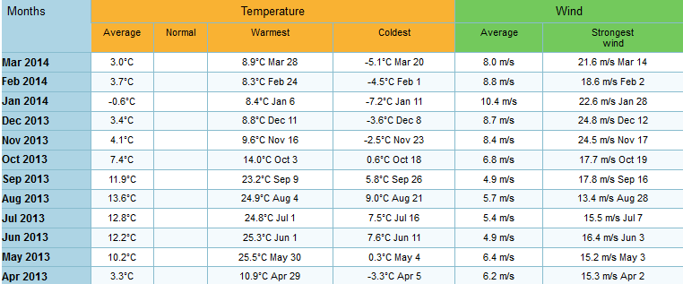

Table 10 Temperature and wind variation, Project Catchment

## Water availability studies

### Hydrological data availability

The hydrology department of the NVE is responsible for operation and measurement of river flow data in Norway. There are no gauging stations in Vassvikelva and hence selection of nearby gauging station has been undertaken. Existence of regulation, catchment size, terrain composition and specific runoff similarity of the gauging station has been cheeked with the project catchment and gauging station at Vassvatnet was found to be attractive as compared to other gouging stations.

Flow data from nearby gauging station at Vassvetnet from 01.09.1916 to 31.12.2013 and water level measurement at the project site from 01.01.2013 to 31.12.2014 are taken as a primary data for analysis.

### Data quality verification

Mass curve representing the accumulated values of hydrological measurement data like discharge or rainfall against time is important tool in identifying any unexplained trends in the variable. In the present study, such mass curve has been prepared for Vassvatnet inflow measurement station. The result of the analysis confirms lack of inconsistency in the data series adopted for analysis.

Having cheeked the consistency of the gauging station the inflow series are scaled to the project site using scaling criteria.

Figure 10 Mass curve gauging station at Vassvatnet

### Scaling of Inflow

Typically a scaling factor close to 1.0 is desired with regard to the comparison of a gauged catchment to an ungauged catchment. As this number becomes further from 1.0 the likelihood of the response to precipitation events between the gauged and ungauged catchments decreases.

Average scaling factor of 0.225 was obtained between the gauging station and the sub-catchments of the main project catchments.

Station Vassvatnet, which is located at coordinates (66043`49`` Latitude: 13010`33`` Longitude) with no known regulation either from existing hydropower schemes or from other water abstractions is used. It is located immediately adjacent to the catchment of interest. It has an area of 16.4 km2. This compares to the project catchment of 22.8 km2. However, given all of the other factors indicates that this is the best station available to the project and it is utilised for the project. The following points are made regarding its implementation within the analysis.

* The flow at the project site may have smaller peaks than experienced in the gauged catchment. This is due to the larger size of the project catchment and the opportunities to buffer the flood flows.
* Data from Station vassvatnet for 97 yrs. period has been utilised in the analysis. This is a complete data series with no missing or erroneous values identified by the project team.

Gauging analysis and data used above are enlisted in annex H-1.

### Flow distribution

The flow values during the year vary markedly both in terms of average flow and maximum / minimum flows. It is noted that there will be exceptions to this data and the analysis undertaken only aims to provide an overview of the likely distribution of the flow pattern.

Figure 11 flow distribution in terms of Indicative parameters

An analysis of the flow pattern during the year has also been undertaken based on daily data. This is displayed in Figure 12. The analysis has been undertaken on 9 individual years, spaced 10 years apart, and is assumed to be representative of the flow patterns in the catchment. It can be seen that the flow throughout the year consists of spikes of high and low flows and there is no consistent pattern which suggest a period of extended low flow which could be used to undertake in-river constructions. It is noted that the period of low flows, February – March, coincide with winter and the worst conditions for construction during the year with regard to access and productivity.

Figure 12 flow distribution over the year

### Flow Duration Analysis

Having prepared the long-term daily average flow series for Smibelg hydro power plant the flow duration curve has been prepared after deducting the minimum environmental flow. The minimum environmental flow magnitude taken above is computed using 95% available flow for summer and winter respectively.

Figure 13 Flow duration curve project catchment FDC

From the FDC curve above, there is a high variability in the flow with a maximum and minimum flow magnitude of 41 and 0m3/s respectively. The mean is computed as 1.92m3/s. however the production output is gained from a high head and storage capacity from Smibelg.

## Flood Analysis

Estimation of design flood is a significant component of hydrological studies. Proper selection of design flood is important as an over-estimated value results cost increase while under-estimation will place a risk to the structure sustainability.

To determine the magnitude of this event a flood frequency analysis was undertaken on both the summer and winter annual maxima series. Prior to the frequency analysis being undertaken, the flood flows were not modified to accommodate that the readings taken were daily readings, rather than instantaneous readings, and likely to underestimate the actual flood maximum.

An EV1, or Gumbel probability distribution was found to be the best fit to the annual maxima series data.

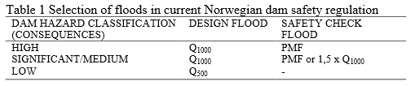

The results of flood frequency analysis are set out in the following table,

|  |  |  |  |  |
| --- | --- | --- | --- | --- |
| Description | Storåga | Øsre storåvatnet | mannåga | østre vakker |
| Consequence class | Class 2 | Class 1 | Class 1 | Class 1 |
| Design flood | Q1000 | Q500 | Q500 | Q500 |
| Dam safety cheek flood | 1.5*Q1000 | Q500 | Q500 | Q500 |
| Mean m3/s | 6.18 | 3.17 | 4.99 | 4.39 |
| St. Deviation m3/s | 2.26 | 1.16 | 1.82 | 1.61 |
| N years | 1000 | 500 | 500 | 500 |
| Gumbel Coefficient K | 4.94 | 4.39 | 4.39 | 4.39 |
| Design flood m3/s | 17.31 | 8.25 | 13.00 | 11.45 |

# GEOLOGY, GROUND CONDITION AND CONSTRUCTION MATERIAL

## Introduction

## Field Investigation

## Geotechnical Appraisal of Project Components

### Dam foundation

### Head Race tunnel HRT

### Power house

## Seismicity

## Limitations

# PROJECT DESCRIPTION

## Scheme Optimization

An initial optimisation was carried out to determine the arrangement and basic sizing of major scheme components prior to a detailed hydraulic and energy analysis being undertaken. The stages in which the optimisation was undertaken are listed below, along with the key outputs from each stage. As each stage was completed the results of that stage were compared against the input parameters from the earlier optimisation stages and an iterative approach taken to ensure that the overall optimum scheme was determined from the process.

The following section outlines the key processes, assumptions and outcomes of each of the optimisation steps.

### Dam and Intake

#### Location

To reduce the number of variables of the optimization progress existing topography of the catchment was used to locate the probable location of the diversion and intake maintaining the planning criteria to maximize the power production from the system.

The system dictated that the diversion structure should be located in the following locations

* Dam at Storåga
* Intake weir at Vakker
* Intake weir at østre storåvatnet
* Intake weir at Mannåga

#### Reservoir and diversion properties

The system layout in the power plant development permits utilization of suitable reservoir system at Smibelgvatnet and Storåga lakes. After iterative optimization and marginal analysis a combined reservoir system serving as a single reservoir connected through tunnel has been proposed as the optimum solution.

The optimisation of the diversion structure was an iterative process. The optimum structure is a function of both the inflows to the intake site and the installed capacity of the plant. The optimisation of diversion height was carried out considering the following factors:

* Outflow capacity from the reservoir as percent of Qmean
* Flow duration curve of the inflow to the reservoir
* Reservoir routing using general water balance
* Reservoir rule using a min reservoir water level of 498masl
* Intake structure level requirements like degree of intake submergence,

The inflow from 97 years data has been used to identify the wet, dry and average years by using flow duration curve for the reservoir optimization, periods occurring 5% of the time as dry, 50% of the time average and 95% of the time as wet are used for optimization analysis.

Figure 14 Yearly Annual flow volume FDC for 97 yrs

The year corresponding to each period is picked representing dry, wet and average year in the following table. Using the inflow from each period optimization of the reservoir capacity and correspondingly the dam height required are analysed and shown in annex H-2.

|  |  |  |  |  |  |
| --- | --- | --- | --- | --- | --- |
|  |  | Smibelg | Storåga | Total |  |
| % of time | Year | Annual volume m3 | Annual volume m3 | Annual volume m3 | Optimum height |
| 50% | 1917 | 17,458,329.60 | 19,012,838.40 | 36,471,168.00 | 4.5 m |
| 5% | 1995 | 24,270,105.60 | 26,431,142.40 | 50,701,248.00 | 5 m |
| 95% | 2010 | 12,740,544.00 | 13,874,976.00 | 26,615,520.00 | 4 m |

Table 11 Data for wet, Dry and average years in terms of annual volume

The outflow from the reservoir has been fixed as 1.25 m3/s , hence it is taken as the maximum design discharge for design of intake structure and constant outflow for reservoir routing. To fix the design discharge S-curve method of reservoir capacity determination is used, a number of trial discharges as a constant demand outflow from the reservoir are cheeked such that the deficit and excess storage are balanced.

Reservoir routing of the above inflow series was undertaken and sample reservoir drawdown is shown the table below for the average year inflow series,

Figure 15 Reservoir Drawdown for 1917

The diversion structure needs to be high enough, such that the pondage created is sufficient for the intake structure. Optimum dam height of 5 m is found to be feasible satisfying intake design requirements. Key project parameters:

|  |  |  |  |  |  |
| --- | --- | --- | --- | --- | --- |
| **Parameter** | **Smibelg-Storåga** | **Mannåga** | **Vakker** | **storåvatn** | **Unit** |
| Diversion crest elevation | 505 | 571 | 495 | 492 | masl |
| Minimum reservoir operation level | 498 | 569 | 493 | 490 | masl |
| Active volume | 9.5 | -- | - - | -- | Mm3 |
| Width | 70 | 100 | 15 | 25 | m |
| Height | 5 | 2 | 2 | 2 | m |

Table 12 key project Parameters

### Water way

Waterways consisting of penstocks, pipes and tunnels are required to convey the water to the power house. The design philosophy involved in fixing the optimum size of waterway is that the sum of following two variables is minimum:

* Annual loss of revenue on account of power loss due to friction in the tunnel.
* Recurring annual expenditure on account of capital cost.

For tunnels the minimum cross sectional area required by contractors for construction is taken as the final design diameter i.e. 16 m2.

|  |  |  |  |
| --- | --- | --- | --- |
| Chainage | Waterway type | Diameter m | Remark |
| CH- 0+000 to 2+444 | Tunnel | 4.5 | Storåga to Smibelg |
| CH- 2+444 to 4+990 | Tunnel | 4.5 | Start of tunnel to Vakker |
| CH- 4+990 to 7+090 | Transfer pipe GRP | 1.3 | Vakker to Storåvatn |
| CH- 7+090 to 8+040 | Tunnel | 4.5 | Storåvatn to start of penstock |
| CH- 0+000 to 1+500 | Tunnel | 4.5 | Mannåga to start of penstock |

Table 13 Water way Description Detail

Optimization of the transfer pipe and penstock for varying design discharge values of (1, 1.25, 1.5 …x Q mean) was undertaken focusing to maintain the philosophy stated above, Marginal analysis of 2xQmea is shown below,

Figure 16 Pipe Optimization 2x Q mean

The result of the study concluded that a 1.3 m diameter GRP pipe will give smallest economic loss and cost of construction cost.

Figure 17 Penstock Optimization 2xQ mean

During the Optimization process the inflow from the reservoir and intra basin transfer are considered in their respective reaches of waterway system. A total inflow comprising contributing sub-catchments and outflow from the reservoir are used for the analysis. For inflows coming from reservoir the above reservoir results from nMag2004 model are used as the outflow discharge. The result of the study concluded that a 1.2 m diameter GRP pipe will give smallest economic loss and cost of construction cost.

A summary of the optimization analysis for pipe and penstock are tabulated at annex H-3.

### Turbine capacity and station installation optimization

Speed number and head available from project are used to identify suitable turbine type for the scheme and for head of 480m and xxx speed number pelton turbines are provided.

After deciding turbine type optimization analysis which will provide the optimum number and capacity of installation units was undertaken for single, two units of equal capacity and 1/3& 2/3x Q design combinations. To arrive at optimum solution varying design discharge magnitudes i.e. (1, 1.25, 1.5 …3xQmean) are cheeked and the optimum combination which will maximize energy production are sought and installation combination of two units of equal capacity are selected.

Summary of optimization procedure for varying discharge are tabulated at annex H-4.

### Design discharge optimization

Optimum installations for tunnel, pipe, diversions, intakes, turbines etc are used to optimize the station installation design discharge. Analysis for varying design discharge magnitudes i.e. (1, 1.25, 1.5 …3xQmean) was undertaken following the procedures shown below,

* Optimum pipe size found from pipe optimization for each design discharge combination are used
* Optimum penstock size found from penstock optimization for each design discharge combination are used
* Cost of intake following each design discharge are computed
* Two units of equal capacity turbine units are selected
* Cost of related electro mechanical installations are derived as per turbine capacity
* All costs are summed and for each design discharge installation
* All benefits of the installation are calculated over the project life time i.e. 50 yrs. using 7% interest rate

Marginal analysis on cost and benefit of installation results optimum design discharge of 2.25 x Q mean for the station installation.

grpah

Summary of optimization procedure for varying discharge are tabulated at annex H-5.

## Civil Design

### Temporary River Diversion Design

### Dam Design

The project as shown in the plan above comprises three diversion intake weirs and main dam at Storåga to form the reservoir. Choice of main dam type at storåga creating a combined reservoir along with Smibelg has been undertaken based on availability of construction material, site topography, depth of overburden and bed rock geology of the dam site.

Available materials

Project area encompasses a good rock quality around the dam site. The tunnels will also be constructed in rock type suitable for dam construction and for concrete aggregate. Clayey, moraine or other type of natural materials suitable for use as low permeability material are not available along the vicinity of dam site hence earth dam is not considered as an option.

Three different dam types have been evaluated as choice of dam at Storåga:

* Concrete faced rock fill dam CFRD

As there are no suitable materials for impervious core it offers advantages like low cement volume, rock fill from excavated tunnel etc. however it requires a spillway on the side or as a separate structure on the dam body.

* Roller compacted concrete dam RCCD

Offers advantages like spillway on the body of the dam, not sensitive to weather condition during construction etc. however it requires extensive amount of cement and salg which are not available in the area.

* Asphaltic moraine core rock fill dam AMCRD

Asphaltic concrete core dams has a core constructed with a special mix of binder in aggregate instead of cement and the core will be impervious and flexible which is of advantage with regard to settlement in the supporting rock fill.

Selected dam type

Asphaltic moraine core rock fill dam with concrete gravity spillway at the river outlet is found to be least cost combination for the dam.

Reservoir features

Existing lakes Smibelg and Storåga are used as a combined reservoir connected with tunnels for the reservoir system. The following reservoir data has been concluded.

|  |  |  |  |
| --- | --- | --- | --- |
| Elevation masl | Volume M m3 | Area M m2 | Remark |
| 498 | 1.25 | 1.23 | LRWL |
| 500 | 3.27 | 1.25 |  |
| 502 | 5.78 | 1.26 |  |
| 504 | 8.33 | 1.28 | HRWL |
| 506 | 10.91 | 1.30 |  |
| 508 | 13.54 | 1.32 |  |

Table 14 Elevation-Area and Elevation -Volume relationship

The optimum regulation limit has been fixed using nMag2004 model using power simulation described in reservoir operation. The following features of the reservoir are selected.

* Highest reservoir water level HRWL : 503 masl
* Lowest regulated water level LRWL : 498 masl
* Live storage Volume M m3 : 5.75 Mm3
* Annual inflow volume M m3 : 36.47 Mm3
* Capacity factor : 15.77%

Spill way design

An ungated spillway with crest elevation at HRWL has been proposed and the corresponding flood magnitude for design of spill way is proposed using a 1000yr return period flood magnitude as design discharge and 1.5xQ1000 as a safety cheek flood as per Norwegian dam safety Regulations.

Design flood Q1000  : 17.31 m3/s

Safety cheek flood 1.5xQ1000 : 25.97 m3/s

Bypass

### Intake design

The function of the intake structure is to allow the smooth entry of water from the reservoir into the water conveyance system. Water is flowing at a low velocity in the reservoir, whereas in the water conductor system flow velocity is in the order of 3 – 6 m/s. intake structures are designed so as to ascertain the smooth entry of water, with transition from lower to high velocity without turbulence and air entrainment into the water conveyance system.

Submergence below minimum draw down level

Adequate submergence below the intake centreline, below the reservoir level, is essential in order to prevent vortices entering into the water conductor system.

* For larger size intakes ( Fr <1/3)

S/D = 1 to 1.5

* For medium and small size intakes (Fr1/3)

S/D = 0.5 + 2xFr

Where S = Min submergence distance between MRL to intake centreline

D = Height of inlet section

* Or using Gordon’s formula as S =1.7*V/

Hence the elevation of centreline and hence the invert as evaluated from the above two criteria is adopted for design.

Flow velocity through trash Rack

Trash racks are provided at the entrance of intake in order to prevent the entry of debris into the water conductor system so as to protect the turbines from objectionably large debris. For mechanical cleaning of racks the velocity at the inlet is taken as 1.5 m/s.

Design result

Design discharge through the intake : 5 m3/s

Minimum drawdown level : 498 masl

Diameter of HRT : 4.5 m

Proposed invert of intake : 492 masl

Intake dimension

It is proposed to provide a rectangular section of 4 m height which will expand later to form 4.5m diameter HRT. Total opening area required at the entrance is 16m2.

Trash rack dimension

Design of trash rack is carried out considering the following:

* Flow at minimum depth of reservoir which gives minimum depth of flow of 6m.
* Net area of trash rack is assumed as 65% of the gross area
* Area of 33% of net area of trash racks assumed to be clogged with trash

It is proposed to provide a single trash rack bays with a width of 4m this gives a flow velocity of 5/(6*4*0.65) = 0.32 m/s on net area of flow. During the clogging condition the velocity increases to 0.96 m/s which is within the permissible limit of 1.5 m/s.

### Waterway design

Head race Tunnel

The present section pertains to design of head race tunnel for each of the three water conductor systems in Smibelg HEP. The design includes fixing the optimum shape, size, rock support and construction Scheduling.

Layout

Circular tunnel with 16 m2 finished area has been proposed with a view to convey 5 m3/s of design discharge from reservoir and intra-basin transfers to power house. Shape of the tunnel is proposed based on method of excavation, use, hydraulic efficiency and size of tunnel. A circular section is hydraulically most efficient section; also circular shape shall carry the external load which shall be carried uniformly by compression.

* Design parameters
* Full Reservoir level FRL = 503 masl
* Min Reservoir level MRL = 498 masl
* Design Discharge = 5 m3/s
* Surface roughness = 0.015
* Rock Type = Granitic Gniess
* Quality = Class I, 60% and Class II, 40%, assumed!

As the size of tunnel is quite small, it is proposed to carry out the excavation by drill and blast with a rail bound transport. Temporary as well as permanent support measures adopted for calculations are dependent on rock quality hence application shall follow the standard design norms.

Head loss Estimation

The loss in HRT comprises major loss due to friction and minor loss at transition, gates and intake.

Friction loss

The friction losses in the tunnel are computed using Darcy equation as:

Friction factor f is calculated using Jains Equation as:

f =

Where:

Construction cost parameters

Tunnel excavation :

Shotcrete :

Rock bolting :

Other miscellaneous items : 10%

Intake design

### Power house

#### Location

#### Configuration and Orientation of Cavern System

#### Tail Race Tunnel and Outfall

# RESERVOIR OPERATION AND POWER PRODUCTION

## Introduction

## Need for Regulation

## Operation Planning

# POWER SYSTEM

## General

## Need for new transmission line

## Assessment of Existing plans

## Transmission system planning and design aspects

## Preliminary Power system analysis ….

# EIA STUDY

## Preliminary EIA

## Preliminary SIA

# COST ESTIMATE

## General

## Estimation Base

## Cost Estimate Civil

## Cost Estimate Electro mechanical

# CONSTRUCTION PLANNING

## General

## Construction Areas

## Project Construction

## Implementation Scheduling

# ECONOMIC ANALYSIS

## Project Assumptions

## Economic Analysis

## Sensitivity Analysis

# CONCLUSION AND RECOMMENDATIONS

# REFERENCE

Erik C. Hicksa, b. H. B. b. C. a. C. D. L., 2000. Seismic activity, inferred crustal stresses and seismotectonics in the Rana region, Northern Norway. *Quaternary Science Reviews,* pp. 1423-1436.

Gunnes, O., 2000. *lecture Notes on Technical and Economic analysis in Hydro power planning.* Trondheim: Norwegin University of Science and Technology.

Hveding, V., 1992. *Hydropower Development in Norway.* Trondheim: Norwegian Institute of Technology.

Killingtvet, Å. & Sælthun, N. R., 1995. *Hydrology, Hydro power Development series.* Trondheim: Norwegian Institute Of Technology, Division of Hydraulic Engineering.

Lavvann,2014. *Norewgian Water Resource.* [Internett]   
Available at: http://gislaugny.nve.no/Geocortex/Essentials/Web/Viewer.aspx?Site=Lavvann&ReloadKey=True  
[Funnet 16 January 2014].

NGU, 2014. *Norwegian geological socity.* [Online]   
Available at: http://www.ngu.no/no/hm/Norges-geologi/Berggrunn/  
[Accessed 4 Feb 2014].

Nilsen, B., 1993. *Rock Engineering.* Trondheim : Norwegian Institute of Technology.

Norway, M. A., 2014. *Norway map.* [Internett]   
Available at: http://www.norgeskart.no/#11/425908/7370864  
[Funnet 01 January 2014].

NVE, 2014. *Norwegian water resource.* [Internett]   
Available at: http:www.nve.no  
[Funnet 21 January 2014].

NVEAtlas, 2014. *Norwegian Water resource.* [Internett]   
Available at: http://atlas.nve.no/ge/Viewer.aspx?Site=NVEAtlas  
[Funnet 16 January 2014].

Raven, J., 1992. *Planning and Impelmenation of Hydro power Projects.* Trondheim: ISBN 82-7598-013-5.

Skår, Ø., 2002. Precambrian Research. *U–Pb geochronology and geochemistry of early Proterozoic rocks of the tectonic basement windows in central Nordland, Caledonides of north-central Norway,* pp. 265-283.

StatnsKraftvek, 2014. *Norgeskart.* [Internett]   
Available at: http://www.norgeskart.no/#12/423924/7368122/+fjelltopper  
[Funnet 18 January 2014].

SWECO Norge AS, 2012. *Norwegian Water Resource Authorithy.* [Internett]   
Available at: http://www.nve.no/en/Newsarchive1/News/Cost-base-for-hydropower-plants-for-downloading/  
[Funnet 5 February 2014].

Volume III Project Drawings

# Annex A Project drawings

Volume IV Project Analysis and Calculations

# Annex B Project various analysis